Usama Bin Hafeez Abbasi

Quiz Application

Login Screen:

Student Interface:

Quiz Interface:

Examiner Interface:

Adding Questions:

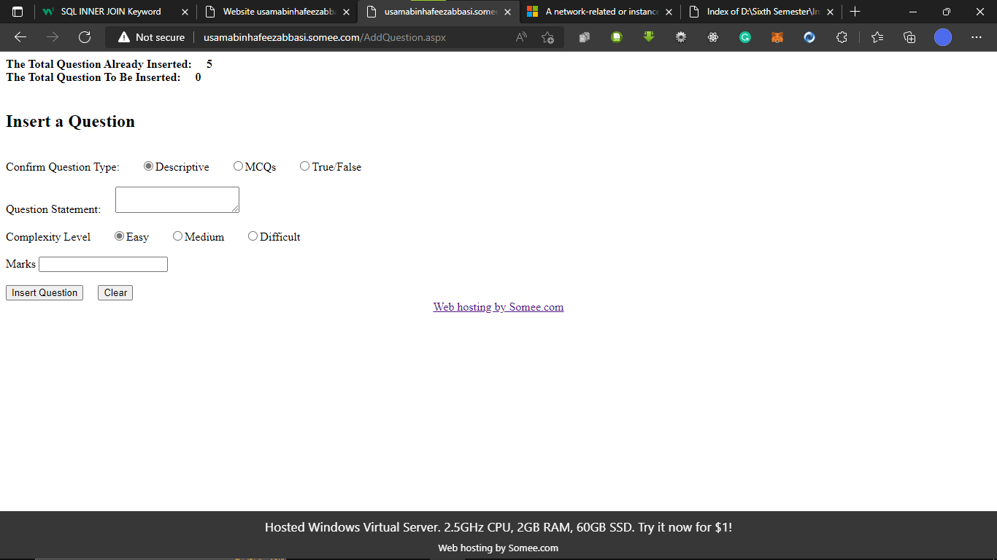

Admin Portal:

Link To Website:

<http://usamabinhafeezabbasi.somee.com/>

Database:

